CMF1114 Lab: Adventure Game Studio
Multimedia Authoring Tool
You will be working in this lab for both Weeks 7 and 8. How you will be scored for the two labs:
- Week 7 - use provided material to learn the engine and build the example game.
  - Change the game flow so that clicking the brush picks it up and adds an inventory item while moving the player to a room where the brush is not visible (and only the two other hotspots are working). In that room, the user can then use the brush inventory item onto the cat to win. OR
  - Redesign the inventory or the ESC menu interfaces so that they look good.
- Week 8 - record your own material during blended learning and come back to prototype interactions/ideas for your assignment to help test ideas for your script/storyboard.

Trying the Example FMV Game
Extract/unzip the provided compressed file for this lab. You should see another compressed file called "Cole's Belly Rub (Example Game).zip" inside - extract/unzip this file into its own folder as well. Once you've done this, you may double-click "CMFTestGame.exe" to run the game.

If you reach the ending too quickly, close and restart the game to see the other options.

Installation
For this lab, we will be using Adventure Game Studio to bring together sound, video and images into interactive multimedia experiences. Download and install the software from their website: https://www.adventuregamestudio.co.uk/ (Windows only!) Use the lab PC if your laptop is not compatible.

Starting a New Game
- The moment you start AGS, you are asked to either load an existing game or start a new game. Pick "Start a new game" here.
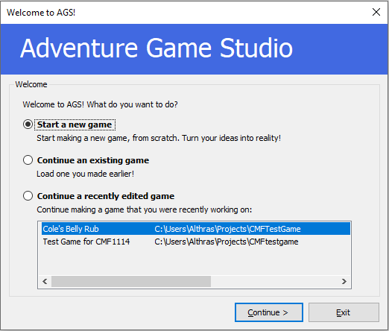
- At the next step, click "Next"
- For the template to base our own game, choose "BASS" and then click "Next":
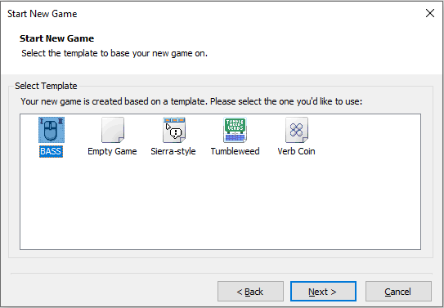
- Assign a name to your game. Read the screen careful to see where these names will be used. Choose your project folder carefully as well. A new folder will be created inside the folder you select here. After you're done, click "Finish".
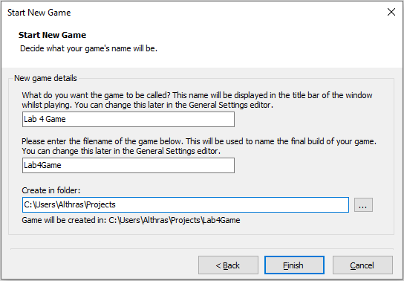
- In the next screen we will arrive at the interface we will be using. Since we used a template, we can already see the basic game pre-created for us by building and running the game (F5 shortcut key) using this button:
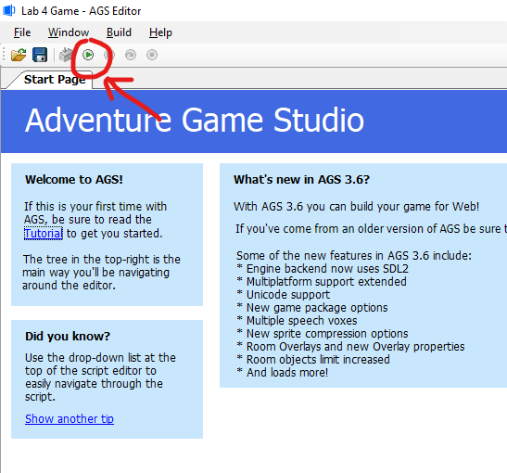
- You should see this game. You can walk around by clicking on the floor. You can click the glowing orb in the middle and get the player character to say something, and you can move your mouse up to reveal an inventory interface:
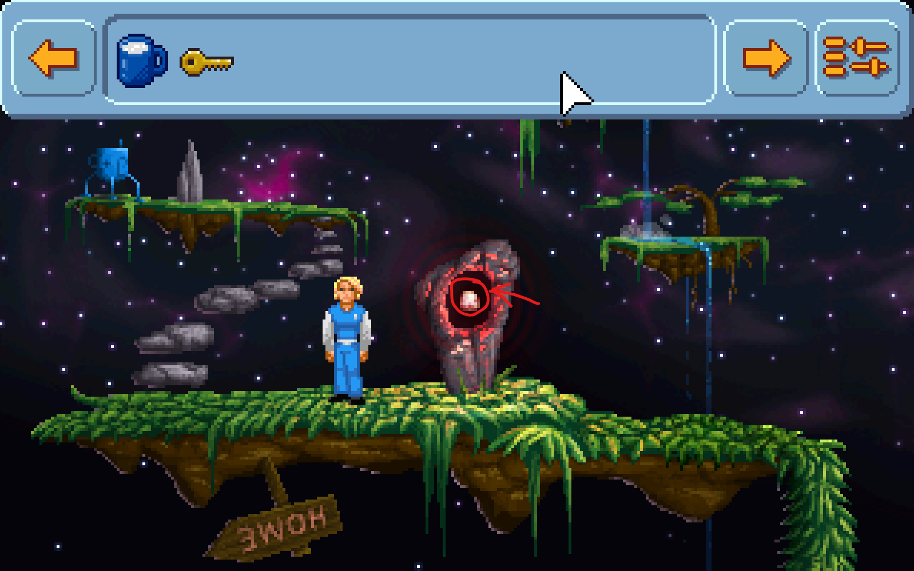
This is not the style of game we want to build. We will not use a player character we can control since we will be using mostly videos, but we will be starting from this point.

Changing to a FMV-style interface
- We have to tweak a few things to make this work. Open the General Settings, and change the Resolution (you have to click "Resolution" to reveal the triple dot button):
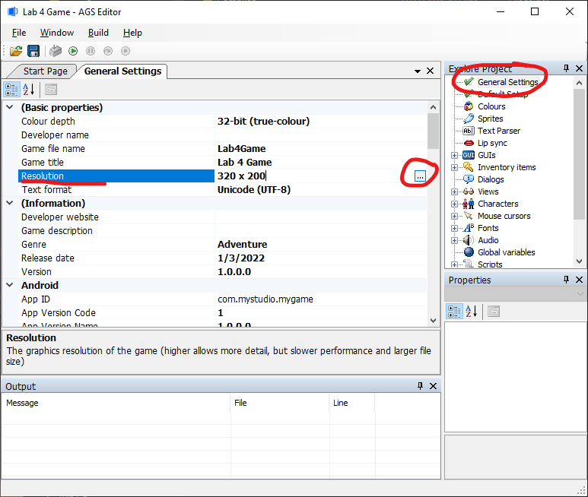
- We'll use a regular video resolution (1280 x 720) and aspect ratio since we're making an FMV game. Click "Yes" when asked if you want to resize your GUIs. (If you try to run the game after this step, the old background will become tiny. Don't worry - we're replacing it later.)
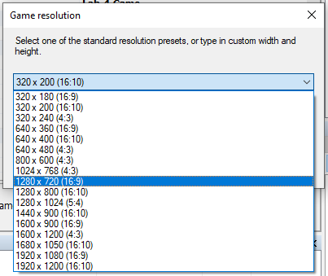
- Next, let's disable the player character. Under the Characters, double click "0: cRoger" to open him for editing. We're focusing on the Properties panel at the bottom right. Change his "StartX", "StartY" and "MovementSpeed" values according to the screenshot below:
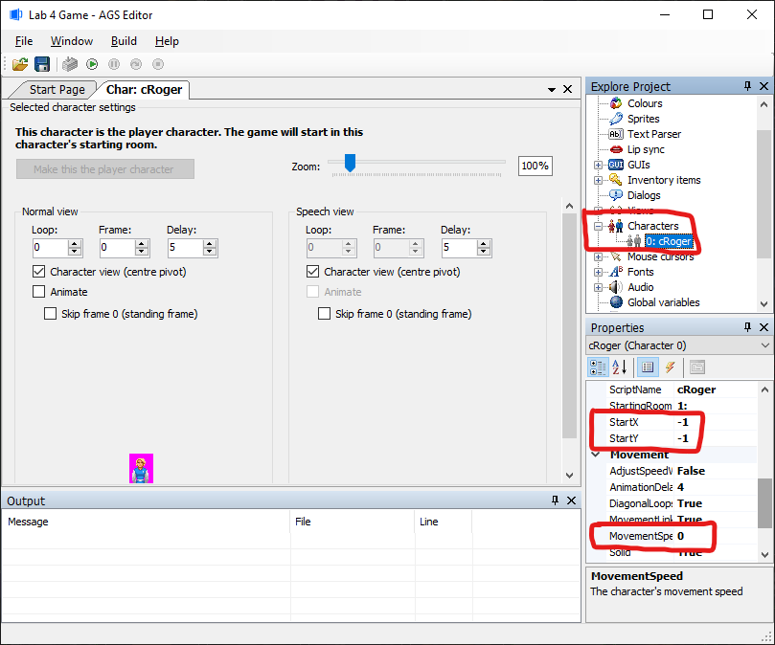
NOTE: This step technically doesn't hide the player character (we will hide him later in room settings), but it positions him off screen so that he can't be seen. Do note that the player.Say() function will position dialogue text based on the position of the character (even if the character is invisible). As you understand the engine better, you may want to move the invisible character somewhere else on the screen if you prefer to use the say function over the Display() function. We also set the movement to zero so that even if he's invisible the character doesn't move around when we click the screen.
NOTE: The "StartingRoom" of cRoger is where the game starts. While building your game, you can change this value to other rooms so that you can skip parts of the game by starting the game where you want to test it.
Optional: You can confirm you did this correctly by running the game again - the player character will be missing. (Your game will look very tiny with the interface looking messed up - don't worry about it for now.)

- Next, we'll hide the character properly. This step HAS TO BE DONE IN EVERY ROOM you create in the future. Open "Rooms -> Room 1 -> Edit Room." Go to the "ShowPlayerCharacter" setting and change it to "False":
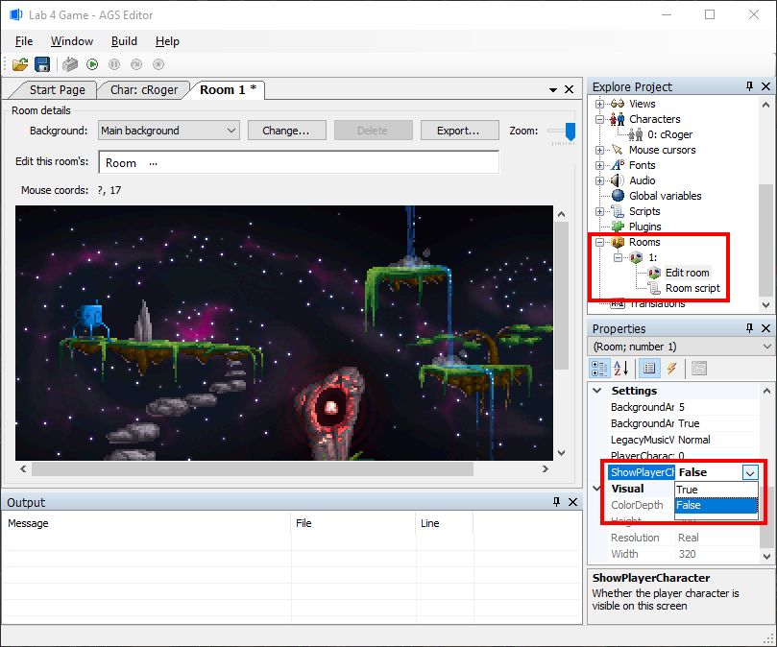
- We need to enlarge our fonts so our text can be seen since our resolution is bigger. Go to "Fonts -> Font 0" and change the "SizeMultiplier" in Properties to 2. Do the same for Font 1 and Font 2:
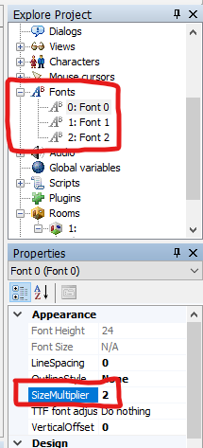
- Next, we hide the inventory interface popping up when we mouse over the top of the game window. Open "Scripts -> TwoClickHandler" and add " interface_inv.Visible = false; " at the exact position shown in the screenshot:
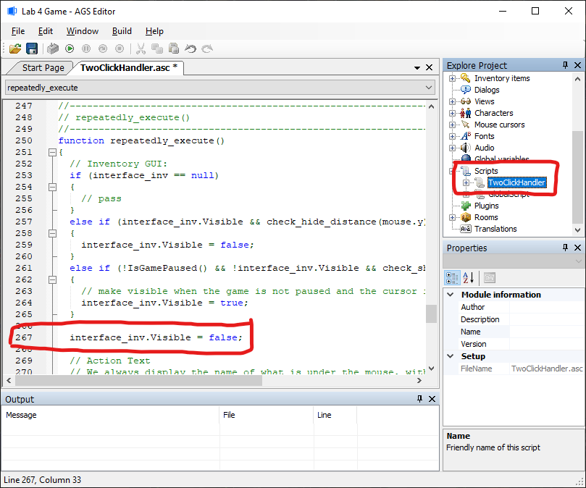
NOTE: If you want to implement an inventory for your game, to make the inventory interface work again, you will have to remove this line.

- We should also hide the ESC menu. Open "Scripts -> GlobalScript" and add " gPanel.Visible = false; " at the exact position shown in the screenshot.
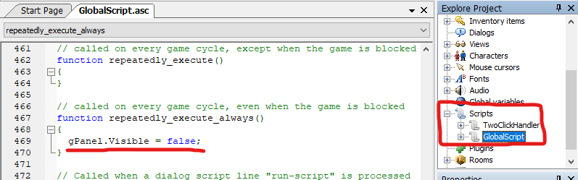
NOTE: You can easily fix the sprites for the menus so that they look presentable instead of hiding them. They are usable – they just need their backgrounds fixed. If you do decide to fix the menu, unhide it by removing this line.

Add Your Videos
For this tutorial you are given some sample image files and some sample videos to use. Images are stored in the save folder automatically when you add sprites or change backgrounds. Videos must be moved into your project's folder manually in Windows Explorer.

- Copy (or cut) the Videos folder from wherever you extracted it. (This is not in AGS, this is in Windows Explorer):
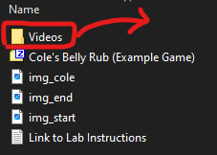
- Go to your project's folder, followed by the "Compiled" subdirectory, and then the "Windows" subdirectory. Paste the Videos folder here:
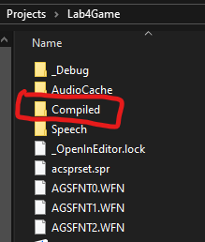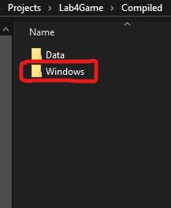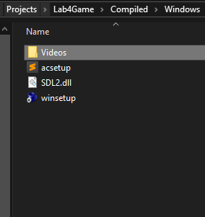
When you're working on your own game later, remember to organise all your videos inside this Videos folder. You are encouraged to name your video files in an organised way and avoid using spaces in your file names to keep things manageable.
IMPORTANT NOTE: When you compile your final game for submission, you can simply build the game, and then compress the whole Windows subdirectory with all the videos inside.
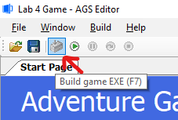

Room 1 – Start Screen + Learning Hotspots
Room 1 is already created for us. We can use this for the starting / title screen of the game.
- Open "Rooms -> Room 1 -> Edit Room" again. You will see the original sample game background. Let's replace it with our simple start screen. The "Main background" should already be selected. Hit the "Change…" button.
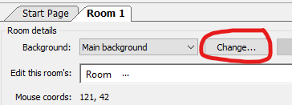
- Select "img_start.png" as your title screen background. You should see this reflected in the game engine.
- Next we will set up our first hotspot (clickable area of the image). Click the "..." after "Room" and select "Hotspots".
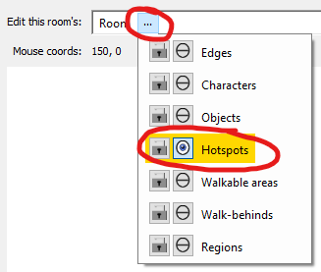
- After that, click the "..." after "Hotspots" and select "hGlowingOrb." This was the old clickable area in the template game – the hotspot is gone after we changed backgrounds. We can reuse/rename it. Use the "Rectangle" tool in the toolbar and draw a rectangle around the "Start" button in the background.
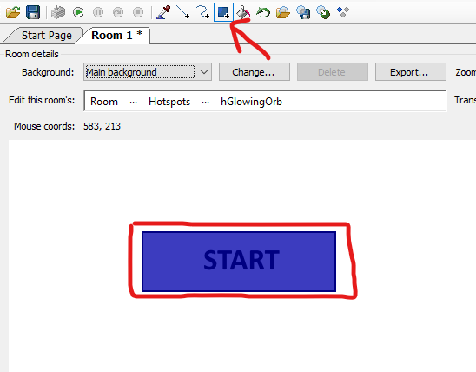
- In the Properties at the bottom right, change the "Description" to "Start Button" and the "Name" to "hStartButton" – note that you can use spaces for the description, but you cannot use spaces for the name. Name here is actually a variable name and in coding we never use spaces for these.
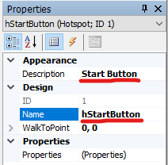
- We've created a hotspot. Try running the game. Try left-clicking and right-clicking on the start button.
  - On left-click, you get - "I can't do anything with it."
  - On right-click, you get - "It is the second best glowing orb that I've seen today."
This is because of the 'events' setting of this hotspot. In the properties tab, click on the lightning icon to see the events related to this hotspot:
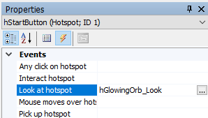
You can see that there's nothing in "Interact hotspot" – that's why it says you can't do anything with it. You can see "hGlowingOrb_Look" in "Look at hotspot" – that's the old script that makes the player say something. Don't do anything for now let's explore further.

- Let's open up Room 1's script:
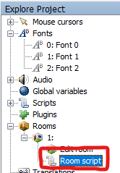
You should be able to see the code that makes the player say the "It is the second best…" line.

- Let's go back to "Room 1"
and go to the Events in its Properties.
- Erase the "hGlowingOrb_Look" under "Look at hotspot", and click on "Any click on hotspot", then click on the "..." button at the end of it.
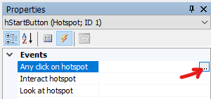
You should see it creating a new function called "hStartButton_AnyClick", assigning it to the properties, and then it will automatically switch you to the room script with the function already written out. You can add your script/commands between the curly brackets { }.
NOTE: If you want to implement both a click (Interact) and right-click (Look-at) in your final game instead of just any click you can! Just make sure you add some guidance (maybe in a help screen) to explain that the two clicks do different things in your game.
- Add the lines below to the function, then delete the old "hGlowingOrb_Look" function completely.

PlayVideo("Videos/vid_start.ogg", eVideoSkipAnyKeyOrMouse, 0);
player.ChangeRoom(2);
Your script for room1.asc should look exactly like this:
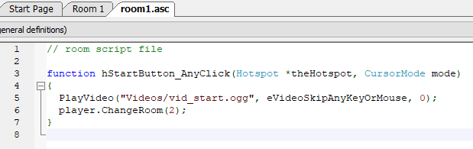
So clicking on the start button will now play the starting video and then lead you to room 2. However, if you run the program (you should!) it will crash after playing the video since room 2 doesn't exist yet.

Room 2 – Branch Point
Now we're going to create that interaction moment/room where you choose between patting the cat's head, rubbing its butt, or using the brush.

- Right click Rooms to create a new room. Click "Ok" to accept the automatically selected items.
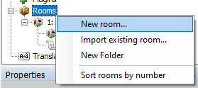
- Don't forget to hide the player character. (Change the room's "ShowPlayerCharacter" property to False.)
- Go to "Edit Room" for Room 2, and change it's background to "img_cole.jpg"
- Go to the room's hotspots, and go to hHotspot1 (there's no old hotspots in this new room).
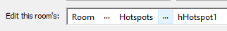
- Let's make this hotspot Cole's head. First draw a line (make sure it touches where it starts for a closed loop) outlining the head using the free draw tool. Your drawing doesn't have to be perfect (since you're outlining a clickable area), but it MUST be a closed loop. It behaves like a brush, drawing wherever you click and drag - so u don't have to draw it all in one motion.
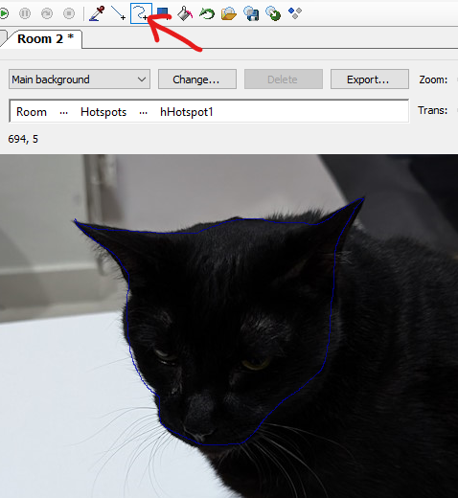
- After that, use the fill bucket to fill in the space within the outline you drew.
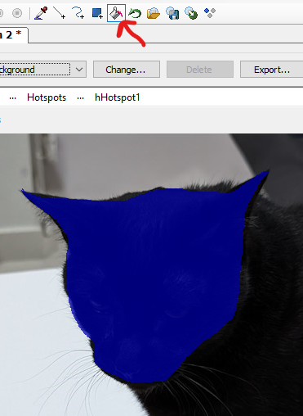
Everywhere that is colored blue is now our hotspot.

- Change the properties as follows:
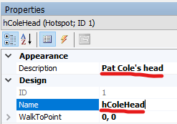
You should have noticed by now we use the small letter 'h' to start every hotspot name to make it easier to identify later.

- Draw and set up the hotspots for "Rub Cole's Butt" / "hColeButt" and "Use Cole's Brush" / "hColeBrush". Don't forget to switch to "hHotspot2" and "hHotspot3" for these. The other hotspots automatically get different colors.
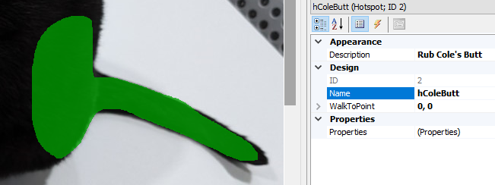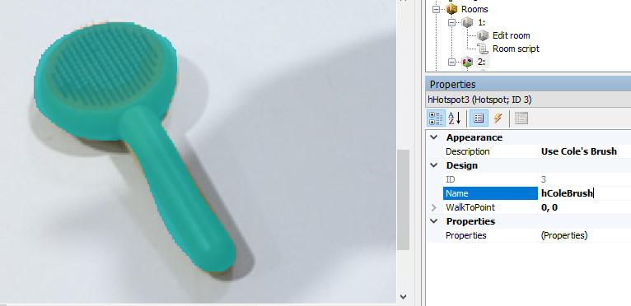
- Now that you have 3 hotspots set up, you can 'choose' them after activating the Picker tool in the toolbar. You can also switch between them using the "..." menu after "Hotspots."
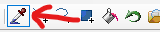
- Let's set up "hColeHead" first. Make sure you have it selected, then go to its events, click on "Any click on hotspot" and then click the '...' button just like earlier:
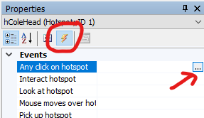
In the script, put in:
PlayVideo("Videos/vid_opt_head.ogg", eVideoSkipAnyKeyOrMouse, 0);
- Next, do the same for "hColeButt". The code you're putting in should now be:
PlayVideo("Videos/vid_opt_butt.ogg", eVideoSkipAnyKeyOrMouse, 0);
- Lastly, for "hColeBrush", there are two lines of code instead since this is the 'correct' solution that moves them to the next room:
PlayVideo("Videos/vid_opt_brush.ogg", eVideoSkipAnyKeyOrMouse, 0);
player.ChangeRoom(3);
NOTE: The "ChangeRoom" function is what makes this the real branch. You can make a story that branches by moving the player to different rooms that play different videos depending on their choices and lead to different parts of the story.
- There's one last thing we want to do in Room 2 which is to add a hint to the players that they can try three different things in the room. For this, you have to go back to Room 2 (make sure a hotspot is not selected):
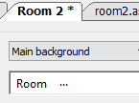
And in Room 2's event, set up the "First time enters room" event:
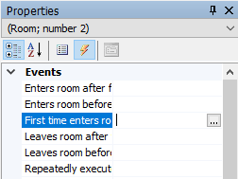
Then write out the function in Room 2's script:
function room_FirstLoad()
{
Display("There are three things you can try!");
}
- Your final script for Room 2 should look like this:
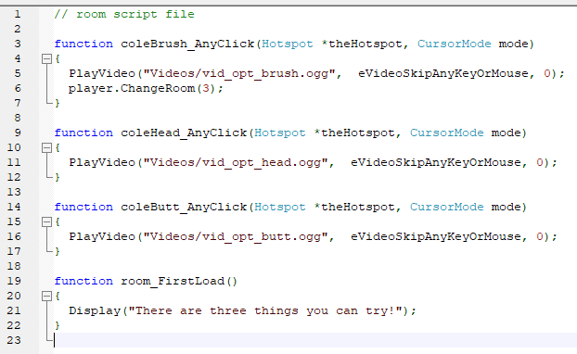
- You should test your game now. Selecting the brush will crash the game since Room 3 doesn't exist yet, but the rest should work fine.
NOTE: You may notice at this point that the descriptions of the choices pop up at the bottom but the color makes it hard to see. This is the action bar - you can access it through "GUIs -> gActionBar" and clicking on the "label text" and changing the "TextColor" property.

Room 3 – Ending/Game Over Screen
- Try to set up room 3's background yourself. Room 3 has no hotspots since it just says "The End". Don't forget to hide the player character again!
- To reward the player by showing them the results of making the right choice, we will play a video the moment they enter this room. We do this from the Events of Room 3 (yes the room itself can have events). Make sure you're editing the room itself:
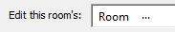
Then as usual, click the '...' button for "Enters room before fade-in" to have the engine create a function in the room's script.
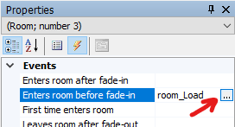
- You should be able to write the "PlayVideo" function for "vid_end.ogg" yourself at this point.

Using Your Own Videos
- To use your own videos with Adventure Game Studio, re-encode them into the ".ogg" Vorbis format, at the 1280 x 720 resolution. You can open them in a video editor and export them into that format. Or find and use a video converter.

Optional Features for Self Learning / Google
- Easy: Enabling the GUIs so that players can use the menu when they press the ESC key. You can do this under the "GUIs" items. You will have to fix the graphics for gExitGame, gRestoreGame, gSaveGame, gPanel and gRestart, but all you have is two things:
  - Draw a bigger GUI background to replace the small blue box. (Click on the grey area outside the GUI to select the GUI itself and see its properties). The current image is uploaded as sprite number 2168. You cannot resize sprites in game - so you have to create an image at the exact pixel resolution/size to fit the interface you're designing in the game.
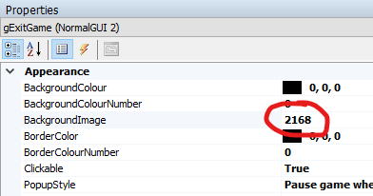

  - Draw two, bigger versions of the button (not pushed and pushed) and replace the small one. (Click on the graphics of the button to select the button and see its properties.)
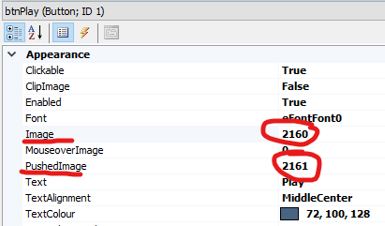
- Hard (actually it's not that hard): Enable and use the Inventory so that players can pick up items, and use those items on hotspots (like using a key on a locked door, or buying the right gift to give to a date.) To do this you have to:
  - Implement inventory items that can be picked up. You can do this by changing to a different room with a background so that an item disappears after it is picked up, or you can learn how to use objects (like hotspots, but images that you can more easily hide.)
  - Learn how to detect when an inventory item is clicked against a hotspot so that players have to choose the right item to succeed.
  - Fix "GUIs -> gInventoryBar" the same way you fix the UI above. You will have to implement new sprites for backgrounds, the inventory space, left and right buttons and the settings button that functions the same as the menu that appears when you press ESC.
You can test this with the example game provided by cutting out an image of the brush and turning it into an item. A version of the background without the brush is provided to you.

Command Quick Reference:

player.Say("..."); | Make the player say the text provided. You can change the color of this text under cRoger's SpeechColor property.
player.ChangeRoom(x); | Change the current room shown to the player. Change x with the room ID.
Display("..."); | Display some text in the center of the screen. Changing its color is complicated.
PlayVideo("Videos/abc.ogg", eVideoSkipAnyKeyOrMouse, 0); | Play abc.ogg file. Change to the name of the video file you wish to play. Put this in ONE LINE.

The full manual for Adventure Game Studio can be found here:
https://adventuregamestudio.github.io/ags-manual/

Working with inventory (optional):

player.AddInventory(xxx) | Adds item named xxx to player's inventory. (You can either move players to rooms where the background no longer shows the item, or learn to use objects in rooms – you can hide objects after players pick them up instead of switching rooms.)
player.HasInventory(xxx)  E.g.  if (player.HasInventory(iKey)) {  Display("I already took the key.");  } | Returns 'true' or 'false' on whether the player has in inventory the item named xxx. Replace xxx with the name of the inventory item to detect.
cRoger.ActiveInventory == xxx  E.g.  if (cRoger.ActiveInventory == iKey)) {  player.ChangeRoom(2);  } | Check if the inventory item being used on a hotspot or object is xxx. Replace xxx with the name of the inventory item to detect.
objectName.Visible = True  objectName.Visible = False | Use this to make an object in a room appear of disappear (after you click it to pick it up and put it into the player inventory.)

